Following a successful overseas International Masters Training Camp in Tenerife Glen Christiansen from Sweden and Nick Gillingham from Great Britain are delighted to announce a further opportunity for Masters Swimmers at the Sennocke Centre, Sevenoaks, Kent, UK.
The Sennocke Centre has all the high quality facilities you would expect for a successful international camp and with two of the World’s greatest breaststroke swimmers together sharing their global swimming and coaching knowledge in the water as well as in the classroom, this swimming experience makes for a unique learning opportunity.
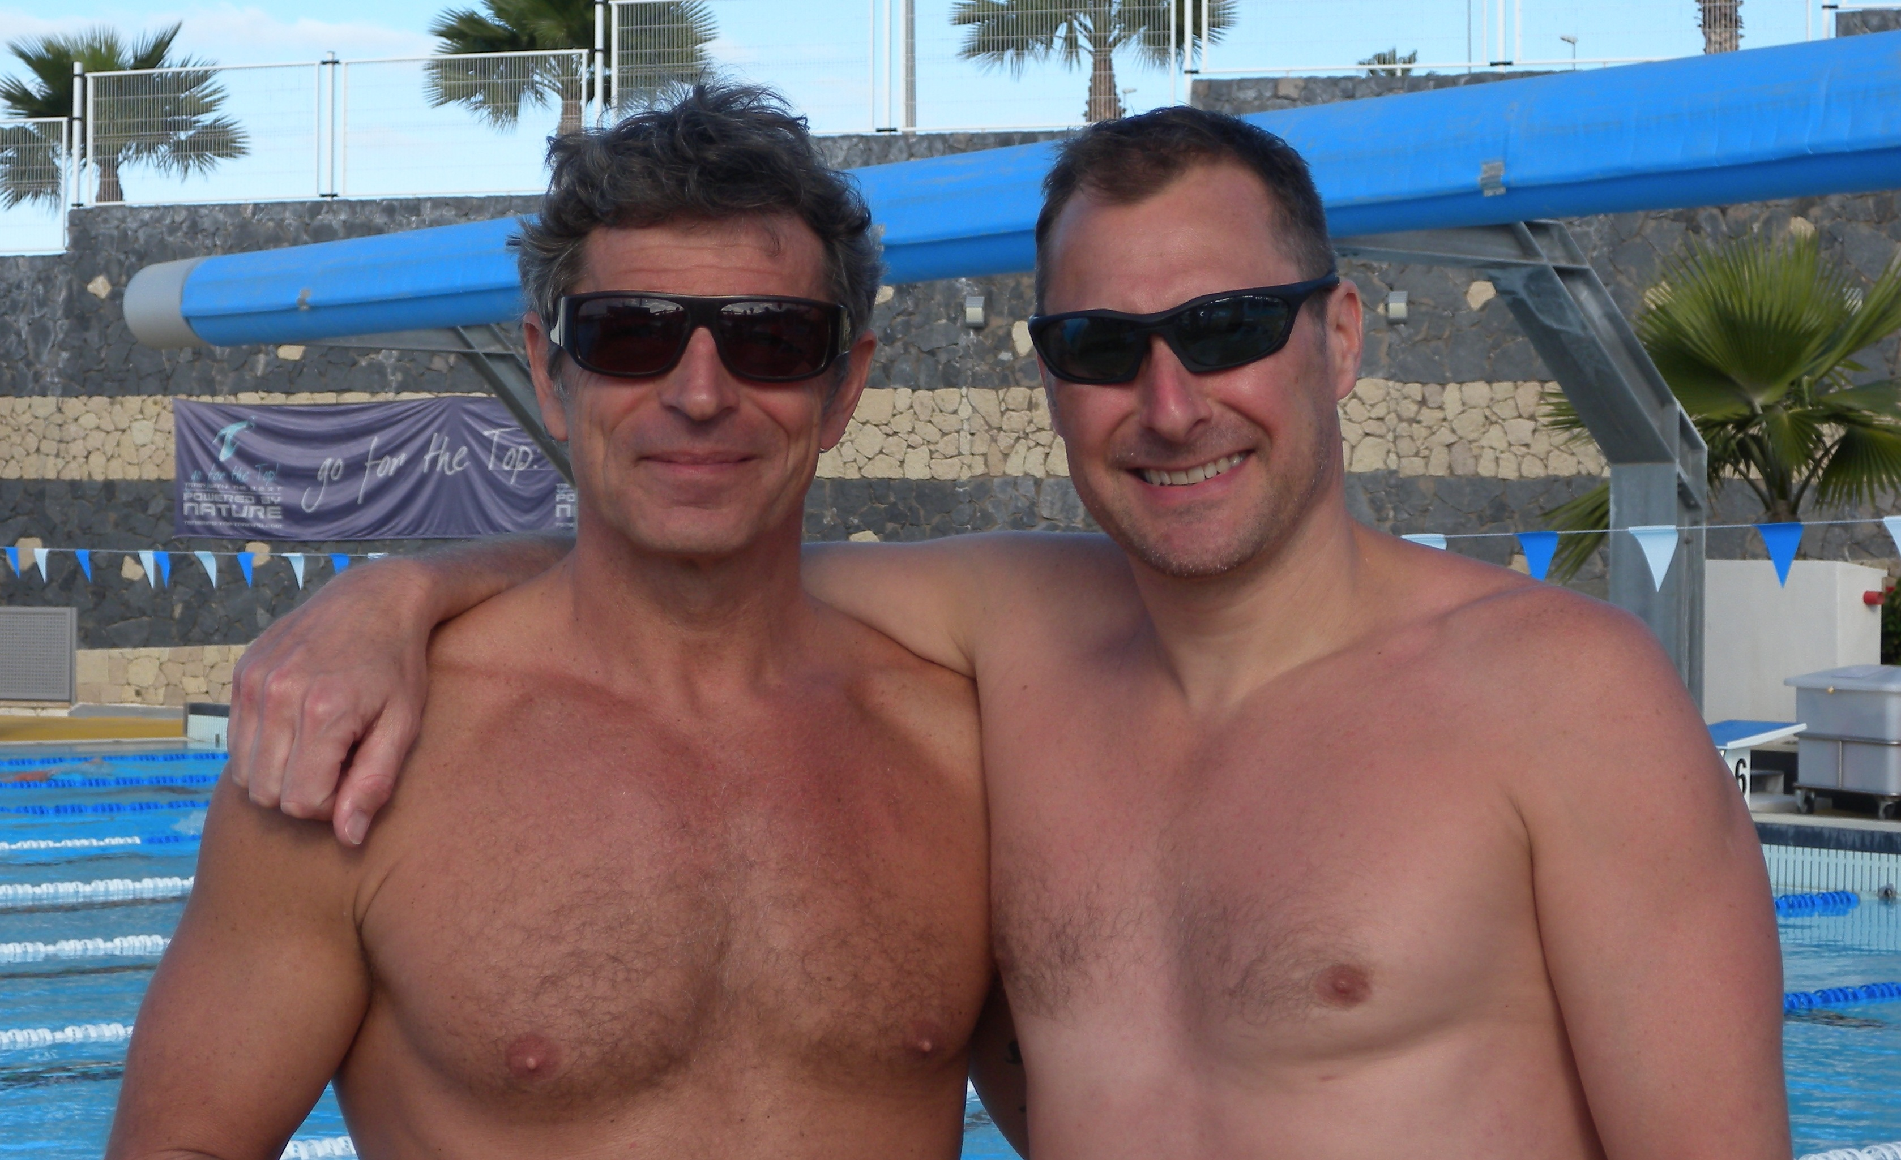
Glen Christiansen has coached at the highest level in Sweden, Germany and Japan and as an Olympic swimmer in 1980 has had a lifetime in the sport. Glen was world ranked no.1 for the 100 metres Breaststroke in 1981 and represented Sweden for 9 years. Glen has enjoyed overwhelming coaching success; He was an Olympic coach in 1996 for Sweden and has placed numerous swimmers onto Olympic teams with medal success. He now thrives on the challenges of multi-strokes and multi-ability camps and dedicates all his time to the organisation and delivery of Masters Swim Camps across the World. He became a World Masters Champion for the first time in 1986 and has since collected 14 World Titles across multiple events. Glen has coached Masters Swimming since 1985 around the world and on behalf of FINA has educated coaches in developing countries world-wide. Over 20 gold medal winners at the last World Masters Championships in Gothenburg were guided to success through his knowledge and dedication to the sport; a charismatic man whose energy for the sport of swimming is second to none.
Nick Gillingham M.B.E., FIOS is a double Olympic medallist swimmer and former World and Commonwealth Champion. Nick has been European Champion on 3 successive occasions rewriting the history books in doing so. Winner of 17 Championship Medals gaining 3 World Records, 9 Commonwealth, 11 European and 17 British Records; he represented Great Britain for 13 years and remains the National Record Holder for England. Nick received the M.B.E. from her Majesty the Queen during the New Years Honours 1993 for ‘Services to Swimming’. He has been a European and World Masters Champion and currently holds European and World Masters Records for the 100 and 200 metres breaststroke. As a licensed performance coach, he has his own NGB approved Swim Academy which remains an integral part of his sports consultancy where Nick is regarded as one of the World’s most technical experts for breaststroke and a well respected inspirational speaker in the UK. He has undertaken extensive mentoring work in education as well as the community for the Youth Sport Trust and Creating Excellence (Sport England), relating to behavioural change and broadening horizons. As the creator of www.swimoptimum.com Nick simply wants to share his knowledge with all swimmers in order to allow the pursuit of personal excellence, to be the best you can be!
Gatwick Airport International Airport is only 30 minutes, see you there.

When: April 8th to 10th 2011
Where: Sevenoaks, Kent. 30 minutes drive from Gatwick.
What: A Swim Camp for Master swimmers focusing on Technique, Speed, Information, Stroke Analysis and Fun!
Whom: You who want to improve your swimming!
How: Information and entry: gc1769@gmail.com
Price: 195,00 GBP (210,00 Euro)
Price including; all training sessions, seminars, stroke analysis, tea and coffee + Camp T-shirt
Accomodation: if you need a place to stay, we can help you!

Schedule:

Friday:
16.00-18.00: Pool with video analysis/Swimoptimum

Saturday:
09.00– 11.00: Pool with Backstroke like a World Champion. Glen Christiansen.
12.00 - 13.00: Lunch
13.00 – 14.00 Theory. Stroke analysis.
14.00 – 15.30: Pool. Mastering Butterfly. Nick Gillingham.
16.00 – 17.00: Theory. How to prepare for a competition. Planning the season.
17.00 – 17.30 Coffee & snacks
18.30 – 20.00: Pool. Focus on Speed + Freestyle technique. Glen.
20.30: Dinner

Sunday:
07.30 – 09.00: Pool. The art of breaststroke. Nick and Glen
09.00-09.30 Coffee & snacks
09.30- 10.15: Theory. How to stay fast as you get older
10.15 – 11.00: Weight training for Masters. (Weight room) Glen
11.30 – 12.00 Lunch
13.00 – 15.00 Swim training. Starts and Turns. Nick

