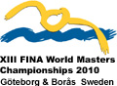

World Masters Swim Camp Hamburg

Come when you want from 19th to 25th of July!

Take the opportunity to train and improve your technique with Olympic Coach Glen Christiansen. The camp is a flexible Come and Go Camp and you only pay for those days you attend! Take the chance to get in shape, do some hard training and improve your swim technique in the beautiful city of Hamburg. Underwater video analysis will be made of your technique. We coach in English, Deutsch and Skandinaviska. Assistance to find accommodation is possible

Come and join us in Hamburg!
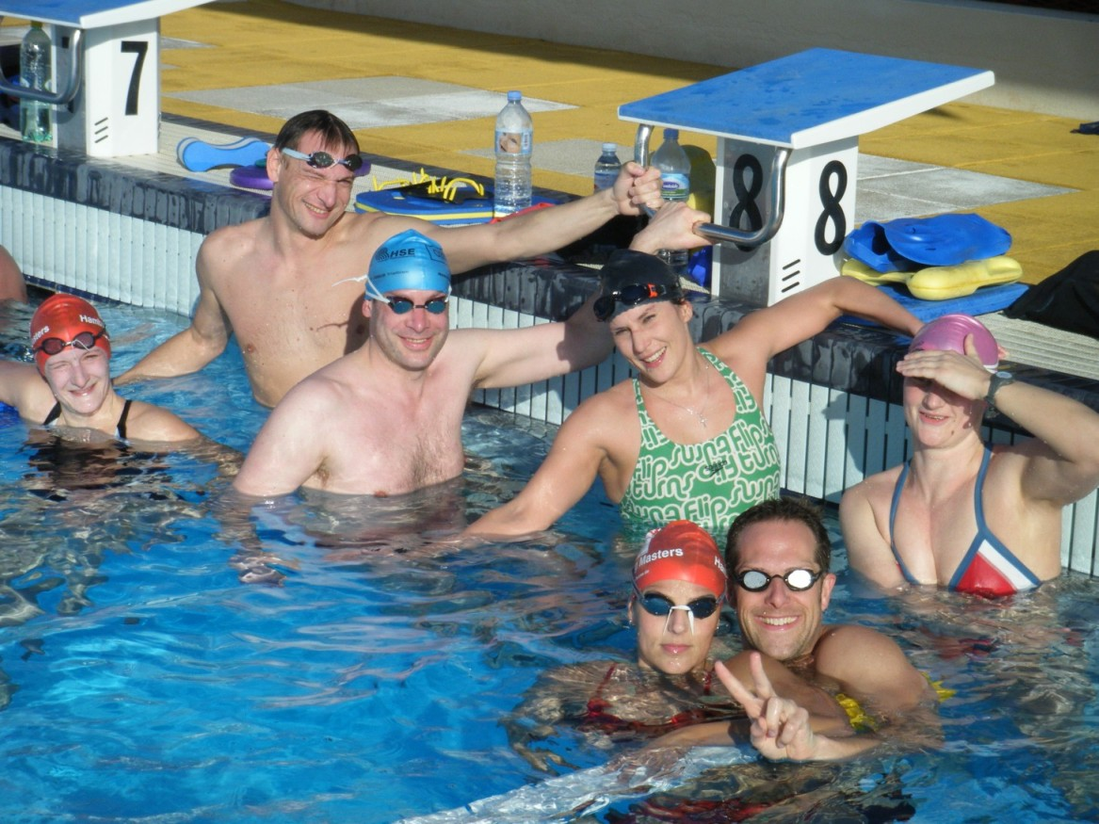

When: 19th to 25th of June 2010. 2 x 2 hours per day.

Where: Poseidon bad 50m outdoor pool, Olloweg, Hamburg.
Me: Coach Glen Christiansen, Olympic Coach and swimmer. 13x World Masters Champion
You: Anyone who wants to improve their swimming. Max 10 swimmers/day!
How: You can book as many or as few days as you want
What: Swim training; technique filming over/under water, sprint, endurance, starts, turns..
Cost: 1 day 40 Euro, 2 days 80 Euro, 3 days 120 Euro and so on....
Entry: gc1769@gmail.com

Program:

Monday-Friday:

09.00-11.00
17.00-19.00

